Lab 6: t-Tests for Two Related Samples

In the previous lab, we worked on the PCAP 2013 data using inferential analysis techniques that focused on group differences between two groups of students. In this lab, we will investigate inferential analysis techniques on two dependent groups of students (e.g., a pre- and post- measure in which the same students are measured both times). **The additional data used in this lab are simulated to provide you with experience working with pre- and post- data. Hence, they are hypothetical and may not be used beyond this lab activity.**

Scenario: After the first PCAP was administered, based on results from the test, the school administrators noticed that bullying was a problem in Alberta. Hence, an aggressive anti-bullying campaign was launched to reduce bullying in schools. The students who had initially reported on the PCAP 2013 bullying items responded to them again after this campaign.

1. Merging two data sets together
The same students responded to the same items after the PCAP 2013 assessment. The data were collected by local school administrators, but each data set was located in a different SPSS file (additional_lab6_data.sav). The two data sets share the following common variable: STUDENT_ID_ELEVE. Download and open the additional SPSS data set for this lab.
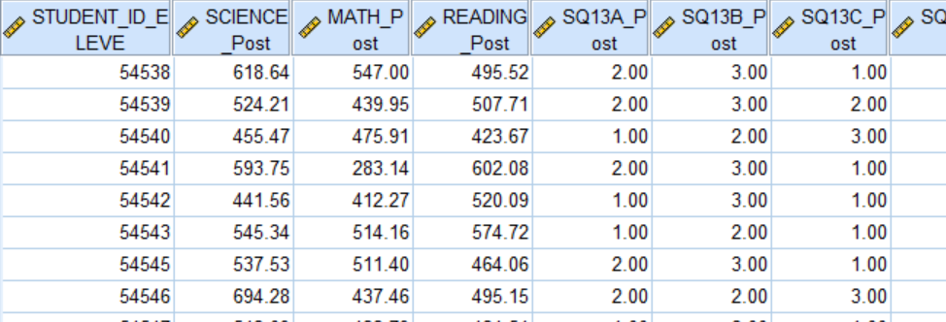

Open your original SPSS PCAP 2013 data set. To merge the new file (additional_lab6_data.sav) to the original file (PCAP2013_Data_Alberta.sav), please select your original PCAP 2013 data and click Data → Merge Files → Add Variable.
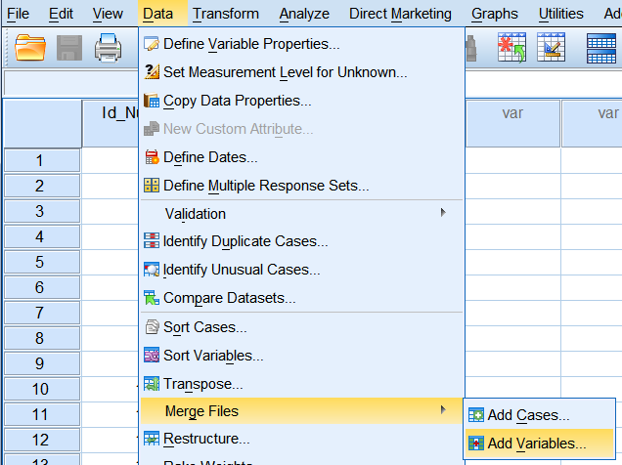
Now search for your new file using the Browse button
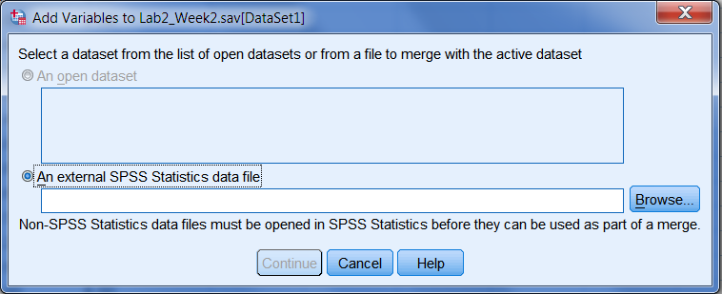

All the variables from both data sets are listed under the New Active Dataset. In order to merge the two data sets, you will need to match up the Student ID. Click the STUDENT_ID_ELEVE variable in the Excluded Variables box. Then click Rename and ensure the New Name matches the name of the Student ID variable in your two SPSS file EXACTLY (case sensitive).
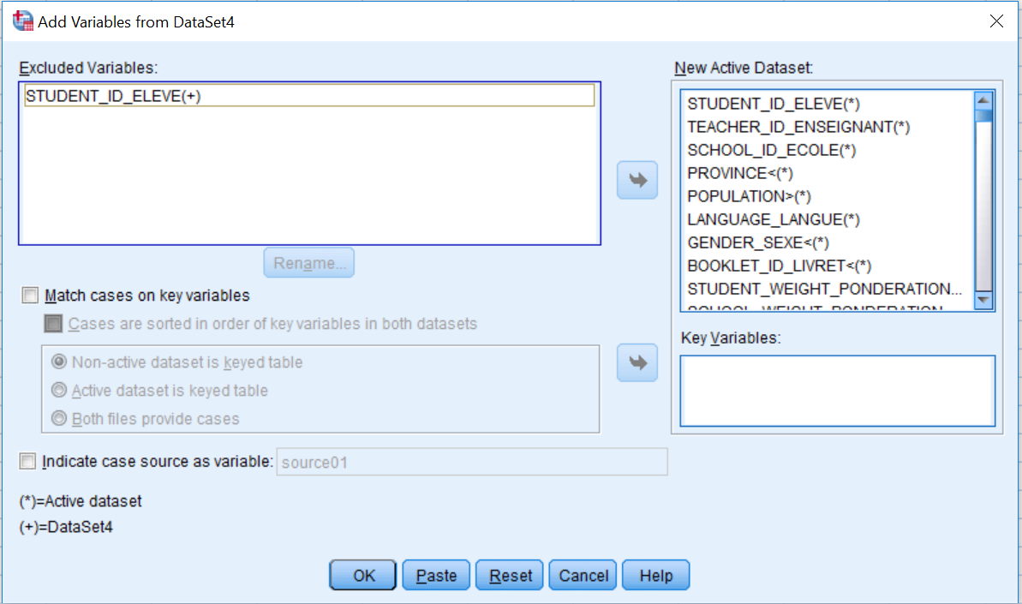
Now click OK. Your data sets should now be merged. The new data is located at the end of your original SPSS file (you will need to scroll to the end to see the newly merged data). Please check a few cases to ensure SPSS merged your two files correctly.

2. Understanding your data set
You are now interested in evaluating this anti-bullying campaign. As a first step, please provide some descriptive analyses of your data.
Question:
- Present your findings in a table that includes the (a) mean, (b) standard deviation, and (c) standard error mean of the pre- and post-data for each bullying item. Please consider APA 6th edition specifications when developing your table.

3. The t-test for two related samples – anti-bullying campaign
Since you are trying to evaluate the anti-bullying campaign, the research question that you are trying to answer is: did the anti-bullying campaign reduce the amount of bullying in schools? Since we have two sets of scores for each student on each bullying item, we will use a related sample t-test. However, before we begin our inferential analyses, we need to ensure our data fits some basic assumptions. In a related-samples analysis, the independence assumption does not hold because the same students are used in both the pre- and post-questionnaires. However, we still need to test for the two other assumptions.
Question:
- Please test the following assumptions:
- normality – Does your sample violate the normality assumption (if you have forgotten how to test for normality, please refer to lab 5, questions 3, 4, and 5)?
- homogeneity of variance – You do not need to test for this assumption during this lab. Testing this assumption requires “dummy coding,” which I will cover during our next class. However, you will need to test this assumption if you are doing a related sample t-test for your future projects.

In order to run a related sample t-test on this sample of students, click Analyze → Compare Means → Paired-Samples T Test → move each pre- and post-item into the Paired Variables box as Variable 1 and Variable 2 → click OK. You will need to enter them one at a time.
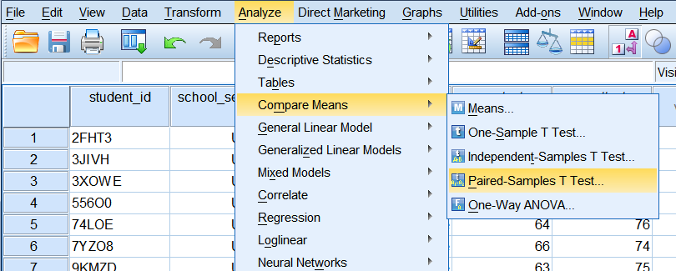
If you find a shortcut to enter all the pre-items and post-items at once, please share that knowledge with me! I am constantly trying to learn new skills in SPSS.
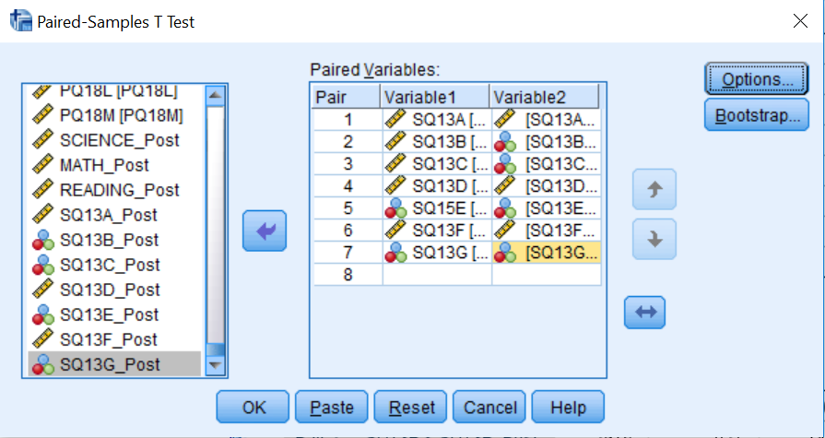
Questions:
- Please write the null hypothesis and alternative hypothesis for this research problem.
- Looking at the Paired-Samples T Test output box, please indicate the: mean difference, standard deviation, standard error mean, t-value, degrees of freedom, and observed p-value. (Note: the mean difference is the difference between the two means you reported in your descriptive table. In the SPSS output it is simply called mean, but in your publications you will need to indicate mean difference to show the difference between the mean reported as part of your descriptive analyses and the mean difference reported as part of your inferential t-test analyses.)
- Looking at the observed p-values, does each mean difference land in the critical region (hint: this is a directional research question)? If yes, which items? (You may need to use Google to search how to calculate the sig. values for a 1-tailed test in SPSS.) Please note, sig. from the SPSS output and p-values of critical areas are not the same concepts.

When running multiple inferential analyses, there is a high risk of inflating the Type 1 error. Hence, we protect against this inflation by completing a Bonferroni correction.
Question:
- Please explain why multiple inferential analyses could increase the likelihood of Type 1 error. (You may need to use Google for this item; please restrict your answer to a few sentences.)

The Bonferroni correction compensates for this increased likelihood of Type 1 error, by reducing the alpha level to which we test for the critical region. The new alpha level using the Bonferroni correction is:
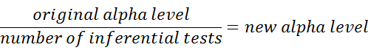
In our case, the new alpha level, which has undergone the Bonferroni correction, will be___???___. You will use this answer in the next set of questions.
Question:
- Please re-analyze your results and indicate which items show a statistically significant difference. Also, indicate these statistically significant differences in your table of results (developed in question 3) by placing a * beside the statistically significant sig. values.
- You will need to report your findings from every item to go along with your inferential results table. Please answer the research question with respect to each bullying item. Answer the question using the format “The anti-bullying campaign made a statistically [significant/non-significant] decrease on students’ self-reported rate of [insert wording from item], t([df]) = [t-value], p[</>]new alpha level.” Please follow APA rules when writing this sentence (e.g., ensure you have italicized the correct t and p symbols). It is important to use the term “statistically [significant/non-significant] difference” because your decision as to whether the result is significant or not should not be based solely on your statistical test. Hence, it is important to tell your readers that this “[significant/non-significant]” difference is a statistical one.

One difficulty in writing these findings is to ensure you include all the technical evidence to support your claims and make the sentence grammatically coherent. In a publication, usually only the statistically significant items would be reported in a sentence format, so that you may further discuss each result.
Questions:
- Using the information from your output, please calculate Cohen’s d and the percentage of variance explained. Theoretically, what do these values indicate? In the context of this study, what does the magnitude of these values indicate to the reader of your study?
- Now, please answer your original research question in a short paragraph: Did the anti-bullying campaign reduce the amount of bullying in schools? You may need to use several quantifying statements and work from each item to ensure you do not over-generalize your results from this analysis. This paragraph is often used in your discussion, so there should be no technical results presented here.

4. The t-test for two related samples – curriculum redesign project
Alberta recently underwent a curriculum redesign project in which the programs of studies used to guide science, math, and reading education were updated. You would like to know whether this curriculum re-design changed students’ achievement in these three subjects, as measured by standardized achievement tests. Students wrote the PCAP 2013 assessment before this redesign and also wrote a similar test at the end of the year. Their results were merged during section 1 of this lab. Please answer the following research question: Did the curriculum redesign change students’ achievement during the first year of its implementation?
Questions:
- Please complete the analyses for this research question. As you answer this question, please include: (a) descriptive table of analyses data, (b) normality assumption test results, (c) an inferential table of t-test results (indicate the statistically significant results in your table), (d) a short paragraph to explain your results (use the proper APA format to convey your findings), (e) Cohen’s d values for applicable variables [include these values in your above paragraph in (d)].
- Please answer the original research question in a brief paragraph, which could be used in your discussion section.

You have now completed the lab.

